Music Streaming User Analysis System
Objective:
The objective of this project is to analyze music streaming data using SQL and generate business insights regarding song popularity, artist performance, genre trends, and user listening patterns.
Dataset Description:
The dataset contains Spotify music information including track names, artists, genres, popularity, danceability, and energy metrics.
SQL Query Analysis
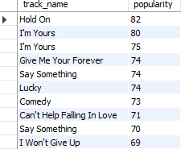
Query 1 - Top Popular Songs RESULT:
SELECT track_name, popularity
FROM spotify_data
ORDER BY popularity DESC
LIMIT 10;

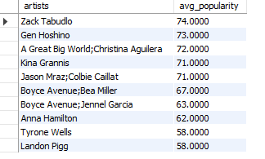
Query 2 - Top Artists RESULT:
SELECT artists,
AVG(popularity) AS avg_popularity
FROM spotify_data
GROUP BY artists
ORDER BY avg_popularity DESC
LIMIT 10;

Query 3 - Genre-wise Song Count RESULT:
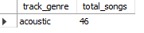
SELECT track_genre,
COUNT(*) AS total_songs
FROM spotify_data
GROUP BY track_genre
ORDER BY total_songs DESC;

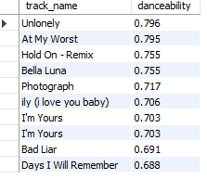
Query 4 - Most Danceable Songs RESULT:
SELECT track_name, danceability
FROM spotify_data
ORDER BY danceability DESC
LIMIT 10;

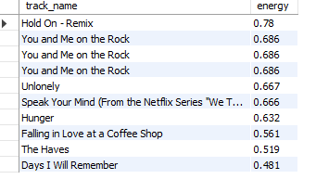
Query 5 - High Energy Songs RESULT:
SELECT track_name, energy
FROM spotify_data
ORDER BY energy DESC
LIMIT 10;

Query 6 - Explicit vs Non-Explicit Songs RESULT:
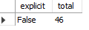
SELECT explicit,
COUNT(*) AS total
FROM spotify_data
GROUP BY explicit;
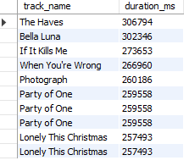
Query 7 — Longest Songs RESULT:
SELECT track_name, duration_ms
FROM spotify_data
ORDER BY duration_ms DESC
LIMIT 10;

Query 8 — Average Popularity by Genre RESULT:
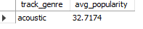
SELECT track_genre,
AVG(popularity) AS avg_popularity
FROM spotify_data
GROUP BY track_genre
ORDER BY avg_popularity DESC;
Business Question Analysis
Which songs are trending?
Songs with the highest popularity scores are currently trending in the dataset.
Which users are highly engaged?
The dataset does not contain user-level engagement information.
Which cities listen most?
The dataset does not contain city or geographical information.
Which genre is performing best?
Genres with higher song counts and average popularity are performing best.
Which users should receive recommendations?
Recommendation systems should target listeners interested in highly popular and energetic songs.
Which users may stop using the app?
The dataset does not contain user listening history, so churn-risk users cannot be identified directly.

Dataset Limitations:
The Kaggle Spotify dataset mainly contains song-level and audio-feature information such as popularity, artists, genres, danceability, and energy. It does not contain user-level data like subscriptions, cities, or listening activity. Therefore, some user-based business analyses could not be performed directly.

Analyst Thinking Questions
Why are some genres more popular?
Some genres become popular because of listener preferences, social media trends, and recommendation algorithms.
How can recommendations improve retention?
Personalized recommendations improve engagement by suggesting songs based on listener preferences.
How would you increase engagement?
Engagement can be improved using trending playlists, notifications, personalized recommendations, and AI-based suggestions.
What dashboard would management need?
Management would benefit from dashboards showing song popularity, artist trends, genre analysis, and recommendation performance.

Business Insights
1. Popular songs receive higher listener attention.
2. Certain artists consistently achieve high popularity.
3. Genre analysis helps identify audience preferences.
4. Danceability and energy influence listener behaviour.
5. Recommendation systems can improve user retention and engagement.

Conclusion:
This project successfully analyzed Spotify music streaming data using SQL queries and generated useful business insights regarding songs, artists, genres, and music trends.

